Exercise #13
1.Which command displays the MSQL version?
SELECT version();
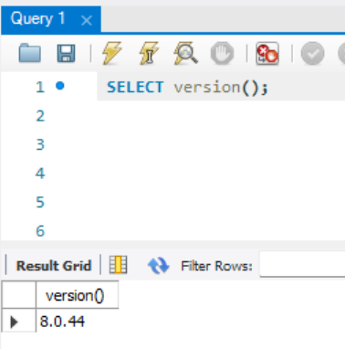
2. Use the Select command to evaluate 4x4x4 and name the column cube of 4.
SELECT 4*4*4 as “Cube of 4”;
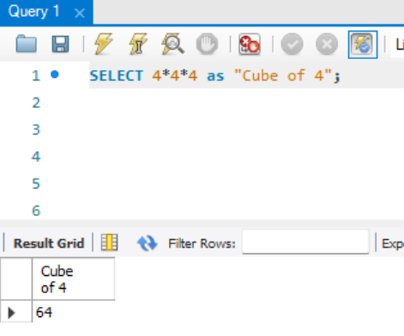

3. Display your name with SELECT.
SELECT “JOHN GEMIL JAVIER” as my_name;
-- I didn’t know that was even possible!
